A Project- I Report

On
MatriCareAI : AI Based Prediction of Labor Related Complications
Submitted by
- Md. Zaid Shamshoddin Sutar (38)
- Aditya Rajesh Kamble (49)
- Sakshi Nagesh Bhumkar (64)
- Varsha Ganesh Devdas (73)

Under Guidance of
Prof. G.N. Chanderki

In partial fulfillment for the award of the degree of Bachelor of Technology

IN
Artificial Intelligence & Data Science Engineering



Pradnya Niketan Education Society, Pune.
NAGESH KARAJAGI ORCHID COLLEGE OF ENGINEERING
& TECHNOLOGY SOLAPUR.

2025-2026



Pradnya Niketan Education Society , Pune.

NAGESH KARAJAGI ORCHID COLLEGE OF ENGG. & TECH., SOLAPUR.

Gut No. 16, Solapur-Tuljapur Road, Tale Hipparaga, Solapur – 413 002 Phone: (0217) 2735001/02, Fax. (0217) 2735004
Certificate

This is to certify that Ms. SAKSHI NAGESH BHUMKAR of class B-Tech (AI&DS) Roll No. 64 has satisfactorily completed the Project-I work entitled “MatriCare AI” as Prescribed by Dr. Babasaheb Ambedkar Technological University Lonere, Maharashtra, India in the academic year 2025-26.
Date of Submission: 22/11/2025

(Prof. G.N. Chanderki) (Dr M. B. Patil)

Mini Project Guide Head of Department
Examiners: (Name with Signature & Date)

- :

- :

Pradnya Niketan Education Society , Pune.

NAGESH KARAJAGI ORCHID COLLEGE OF ENGG. & TECH., SOLAPUR.

Gut No. 16, Solapur-Tuljapur Road, Tale Hipparaga, Solapur – 413 002 Phone: (0217) 2735001/02, Fax. (0217) 2735004
Certificate

This is to certify that Ms. VARSHA GANESH DEVDAS of class B-Tech (AI&DS) Roll No. 75 has satisfactorily completed the Project-I work entitled “MatriCare AI” as Prescribed by Dr. Babasaheb Ambedkar Technological University Lonere, Maharashtra, India in the academic year 2025-26.
Date of Submission: 22/11/2025

(Prof. G.N. Chanderki) (Dr M. B. Patil)

Mini Project Guide Head of Department
Examiners: (Name with Signature & Date)

- :

- :

Pradnya Niketan Education Society , Pune.

NAGESH KARAJAGI ORCHID COLLEGE OF ENGG. & TECH., SOLAPUR.

Gut No. 16, Solapur-Tuljapur Road, Tale Hipparaga, Solapur – 413 002 Phone: (0217) 2735001/02, Fax. (0217) 2735004
Certificate

This is to certify that MR. MD. ZAID SHAMSHODDIN SUTAR of class B-Tech (AI&DS) Roll No. 38 has satisfactorily completed the Project-I work entitled “MatriCare AI” as Prescribed by Dr. Babasaheb Ambedkar Technological University Lonere, Maharashtra, India in the academic year 2025-26.
Date of Submission: 22/11/2025

(Prof. G.N. Chanderki) (Dr M. B. Patil)

Mini Project Guide Head of Department
Examiners: (Name with Signature & Date)

1:

2:

Pradnya Niketan Education Society , Pune.

NAGESH KARAJAGI ORCHID COLLEGE OF ENGG. & TECH., SOLAPUR.

Gut No. 16, Solapur-Tuljapur Road, Tale Hipparaga, Solapur – 413 002 Phone: (0217) 2735001/02, Fax. (0217) 2735004
Certificate

This is to certify that MR. ADITYA RAJESH KAMBLE of class B-Tech (AI&DS) Roll No. 49 has satisfactorily completed the Project-I work entitled “MatriCare AI” as Prescribed by Dr. Babasaheb Ambedkar Technological University Lonere, Maharashtra, India in the academic year 2025-26.
Date of Submission: 22/11/2025

(Prof. G.N. Chanderki) (Dr M. B. Patil)

Mini Project Guide Head of Department
Examiners: (Name with Signature & Date)

1:

2:

ABSTRACT

Maternal health complications such as hemorrhage, hypertension, infection, and fetal distress remain major contributors to maternal mortality worldwide, particularly in low-resource settings where continuous monitoring and timely clinical intervention are limited. To address this critical gap, MatriCare AI introduces an intelligent, dual-module maternal monitoring system that combines machine learning–based risk prediction with advanced LLM-driven clinical decision support.
The first module is an automatic continuous monitoring system that processes eight physiological parameters in real time using a trained Random Forest model to classify maternal status as Stable, Moderate, or Critical. The second module analyzes nineteen detailed maternal parameters, applies rule-based logic, and uses an LLM with semantic retrieval to generate context-aware insights, including future complications and both basic (nurse-level) and advanced (doctor-level) actions.
By integrating real-time prediction, medical rule matching, and natural-language clinical suggestions, MatriCare AI functions as a comprehensive decision-support system aimed at reducing diagnostic delays and empowering healthcare workers. The project demonstrates significant potential for enhancing maternal safety, improving early warning capabilities, and supporting clinical decision-making in both hospital and low-resource environments

ACKNOWLEDGEMENT

We would like to extend our acknowledgement to all those who have been very helpful to complete our mini project. We would like to express our deep sense of gratitude to our guide Prof. G.N. Chanderki mam for inspiring guidance due to which our difficulties and questions were shaped into the development of the mini project. His words of inspiration always encouraged us to work hard and finish it on time.

We also take this opportunity to express a deep sense of gratitude towards Dr. M. B. Patil Sir, Head of Artificial Intelligence and Data Science Department, for valuable guidance and support. We are also thankful to Dr. B. K. Songe Sir, Principle, N.K. Orchid College of Engineering and Technology, Solapur for making facilities available to us.

Date: 24/11/2025 Student’s Names:
- Md. Zaid Shamshoddin Sutar (38)
- Aditya Rajesh Kamble (49)
- Sakshi Nagesh Bhumkar (64)
- Varsha Ganesh Devdas (73)

INDEX

SR. NO | TITLE | PAGE NO.
1 | INTRODUCTION……………………………………  1.1 Motivation………………………………………  1.2 Problem Statement……………………………...  1.3 Summary……………………………………….. | 9  9  9  10
2 | LITERATURE REVIEW…………………………..  2.1 Literature Review………………………………  2.2 Gap Identification………………………………  2.3 Summary………………………………………. | 12  12  13  14
3 | MEHODOLOGY……………………………………  3.1 Diagrams……………………………………….  3.2 Algorithms……………………………………..  3.3 Summary………………………………………. | 15  15  18  20
4 | IMPLEMENTATION……………………………….  4.1 Workflow Details………………………………  4.2 Testing and Validation…………………………  4.3 Summary………………………………………. | 21  21  24  27
5 | RESULT & DISCUSSION………………………….  5.1 Results…………………………………………..  5.2 Comparative Analysis…………………………..  5.3 Summary……………………………………….. | 28  28  30  32
6 | CONCLUSION AND FUTURE WORK……………  6.1 Limitations……………………………………...  6.2 Future Work……………………………………. | 33  33  34
 | REFERNCES………………………………………… | 36
 | APPENDICES………………………………………… | 38

CHAPTER I - INTRODUCTION
1.1 Motivation
Maternal mortality and childbirth-related complications continue to be a major global health challenge, particularly in low- and middle-income countries. According to the World Health Organization (WHO, 2023), over 800 women die every single day due to preventable pregnancy and childbirth complications. Nearly 94% of these deaths occur in low-resource regions, where shortage of skilled staff, lack of monitoring devices, and delayed interventions remain common issues.
Complications such as postpartum hemorrhage, preeclampsia, infections, and obstructed labor contribute to nearly 75% of all maternal deaths (UNFPA–WHO Report, 2022). In India, the situation—though improving—remains concerning, with a Maternal Mortality Ratio (MMR) of 97 per 100,000 live births (SRS 2023). Studies indicate that most maternal deaths occur within 24 hours of delivery, a period that demands continuous observation and fast decision-making.
However, due to overburdened hospitals, shortage of trained staff, and lack of modern monitoring tools, early detection of complications often fails. Reports also show that 60–70% of rural healthcare centers lack continuous maternal monitoring systems, leading to missed warning signs and preventable deaths (NITI Aayog Healthcare Report, 2022).
These realities motivate the development of intelligent systems capable of enhancing clinical decision-making. MatriCare AI is driven by the need to:
- Reduce delays in diagnosis
- Provide automated, continuous monitoring
- Support healthcare workers with real-time predictions
- Enable faster and more accurate responses to emergencies

By integrating machine learning with LLM-based reasoning, the solution aims to create a reliable, low-cost system that can assist even in low-resource environments—ultimately helping reduce preventable maternal complications and fatalities.

1.2 Problem Statement
Pregnant women, especially during labor and the postpartum stage, require continuous and multi-parameter monitoring to detect complications early. Existing monitoring systems often focus on only a few parameters, such as fetal heart rate or uterine contractions, and lack the ability to integrate diverse maternal indicators such as blood pressure, oxygen saturation, fatigue, pain level, hydration, or emotional state. This fragmented monitoring results in delayed diagnosis and slow intervention.
Additionally, traditional systems do not provide actionable insights. They may display raw vitals, but do not analyze trends, predict upcoming risks, or guide clinicians with context-aware suggestions. In many cases, healthcare workers—especially in rural clinics—lack decision-support tools that can help them respond effectively during emergencies.

The problem becomes more severe in low-resource environments where:
- Skilled nurses and obstetricians are limited
- Monitoring devices are outdated or unavailable
- Real-time analytics are missing
- Staff are overloaded and unable to track every patient continuously
- No system exists to classify risk levels automatically

Therefore, there is a pressing need for an automated solution that can:
- Continuously monitor essential maternal parameters
- Classify the severity of complications in real-time
- Provide intelligent, medically relevant suggestions
- Assist healthcare workers in making fast, accurate decisions

MatriCare AI addresses this gap by integrating a continuous ML prediction model with an LLM-based clinical guidance module to deliver a comprehensive and intelligent maternal monitoring system.

1.3 Summary
This chapter introduced the broader context and the driving forces behind the development of MatriCare AI. It highlighted the critical global and national challenges in maternal healthcare, supported by statistical evidence showing the scale of preventable maternal deaths and the lack of adequate monitoring tools in many healthcare settings. The discussion outlined the real-world issues—such as delayed diagnosis, inadequate continuous monitoring, and limited decision-support systems—which create a strong necessity for AI-driven maternal care innovations.
The problem statement emphasized the gap between traditional monitoring systems and the need for automated, intelligent platforms capable of evaluating multiple parameters, predicting risk levels, and offering actionable recommendations. MatriCare AI is presented as a response to these challenges, integrating machine learning and LLM reasoning to create a comprehensive maternal monitoring system.
Overall, the chapter establishes a strong foundation for the project by explaining why such a system is essential, how it addresses current limitations, and why it is relevant and timely in the global healthcare landscape.

CHAPTER II - LITERATURE REVIEW

2.1 Literature Review
AI is increasingly being used in maternal healthcare to predict complications and support clinical decisions. Research in this field focuses on using machine learning, deep learning, and rule-based systems to analyze maternal parameters and improve early intervention. The following literature review highlights key studies contributing to this growing domain.[1] Recent advancements in artificial intelligence have enabled continuous surveillance of maternal vitals, reducing delays in detecting life-threatening complications. Deep learning models trained on physiological data can automatically identify abnormalities such as hypertension, tachycardia, fetal distress, and poor oxygen saturation. This automation supports clinicians who often face high workloads, especially in low-resource environments.[2] Recent advancements in artificial intelligence have enabled continuous surveillance of maternal vitals, reducing delays in detecting life-threatening complications. Deep learning models trained on physiological data can automatically identify abnormalities such as hypertension, tachycardia, fetal distress, and poor oxygen saturation. This automation supports clinicians who often face high workloads, especially in low-resource environments.[3] Machine learning algorithms such as Random Forest, XGBoost, SVMs, and Neural Networks are increasingly applied to maternal health datasets to classify risk levels (normal/moderate/critical). These models learn patterns from physiological data and create decision boundaries that outperform traditional rule-based clinical systems. [4] Natural Language Processing (NLP) models are being introduced to interpret clinical notes, summarize patient conditions, and recommend actions. LLMs integrated with structured rules can generate contextual recommendations tailored to individual patient parameters.[5] Multimodal systems process both numerical sensor data and medical guidelines to produce holistic insights. This approach mirrors real clinical scenarios wherein doctors combine objective vitals with subjective observations. [6] Knowledge graphs map relationships between symptoms, complications, medical interventions, and outcomes. AI systems referencing these graphs improve accuracy in early detection and ensure recommendations remain aligned with standard medical guidelines.[7] Rule-based clinical frameworks often define threshold-based responses, such as “if BP < 90/60, initiate shock protocol.”

Integrating these clinical rules with AI-generated contextual explanations creates hybrid systems capable of producing more personalized recommendations.[8] Techniques such as SHAP, LIME, and decision-tree visualization help clinicians understand why a model classified a patient as critical, increasing clinician trust and regulatory acceptance. [9] Since maternal complications often involve multiple co-occurring factors, multilabel classification has become vital. These models can detect simultaneous risks—like high BP, fever, and low SpO₂—offering a more realistic representation of maternal conditions.[10]Real-time data streaming architectures allow processing continuous sensor data without delays. Techniques like sliding-window analysis and online learning ensure predictions remain current and accurate.[11] To address connectivity limitations, AI models can be deployed on edge devices such as mobile phones, wearable sensors, or microcontrollers. This reduces dependence on cloud-based computation, especially in rural areas.[12] AI systems now also consider emotional and psychological factors such as fatigue, stress, and mood. These indicators are strong predictors of adverse maternal outcomes but are often overlooked in traditional monitoring.[13] Longitudinal AI models evaluate changes in vitals over time rather than single measurements. Trend-based analysis improves prediction of complications like progressive hypertension or worsening anemia.[14] AI-driven risk alerts help hospitals prioritize patients, allocate resources efficiently, and reduce nurse workload. Automated triage systems are increasingly seen as essential components of modern maternal care.[15] Large Language Models can convert complex clinical guidelines into simplified operational actions for bedside staff. This allows seamless translation of evidence-based protocols into practical steps.[16] AI does not replace medical personnel but acts as a supportive tool that enhances vigilance. Nurses can use AI alerts to act faster, while doctors can use predictive insights to decide advanced interventions.[17] Model outputs adapt dynamically to each patient’s baseline vitals, medical history, and biometrics, offering individualized recommendations rather than generalized warnings.[18] Despite progress, rigorous clinical validation remains necessary. AI models must be tested across diverse populations to ensure reliability, fairness, and safety. Regulatory standards like FDA/CE compliance are vital for adoption.

  - Gap Identification
Although multiple studies exist on maternal monitoring, most suffer from significant gaps:
- Lack of continuous real-time monitoring systems
- Models focus mainly on fetal parameters, ignoring maternal vitals
- Limited systems integrate machine learning with reasoning-based suggestions
- No unified platform combining predictions + clinical guidance
- Existing solutions require expensive hardware
- Most research doesn’t focus on low-resource environments like rural hospitals
- Limited datasets for maternal healthcare
This project bridges these gaps by integrating ML and LLM modules to provide holistic monitoring.

2.3 Summary
This chapter provided a detailed review of existing research and technologies related to maternal health monitoring, early complication prediction, and AI-driven clinical decision support. It highlighted the strengths of prior work, such as the use of machine learning for risk prediction, wearable sensors for continuous monitoring, and LLM-based systems for medical guidance. At the same time, the review also identified several critical limitations in current studies — including incomplete parameter coverage, lack of real-time monitoring, absence of integrated maternal–fetal datasets, and limited decision-support capabilities for nurses and doctors.
By comparing these research efforts and exposing their shortcomings, this chapter established a clear research gap: the need for a unified, real-time, AI-assisted maternal monitoring system that combines continuous ML prediction with LLM-based contextual analysis and actionable clinical guidance. This gap forms the foundation for MatriCare AI’s innovation and justifies the methodology adopted in the following chapter.

CHAPTER III - METHODOLOGY

3.1 Diagrams
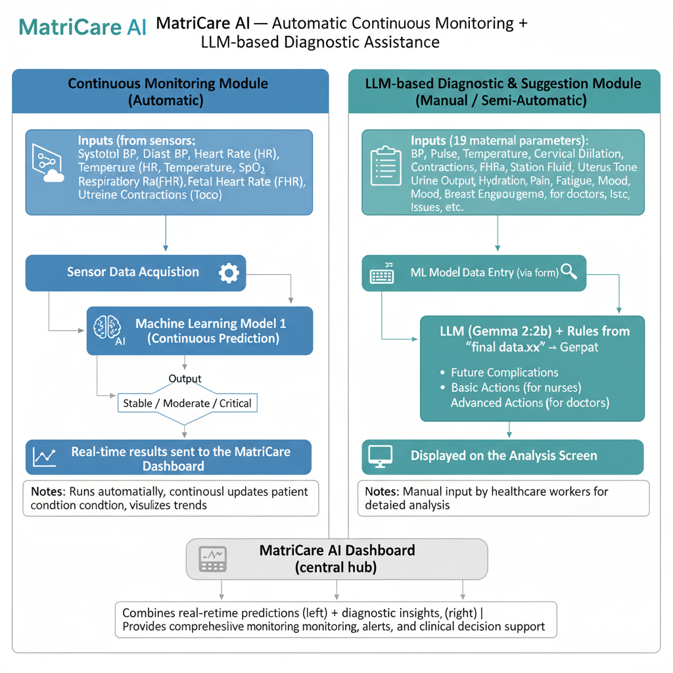
The methodology of MatriCare AI is structured into two major modules, each addressing a different aspect of maternal monitoring and clinical decision support. Together, they form an integrated pipeline that analyzes patient data, predicts risk levels, and generates medically relevant guidance.
Fig.3.1.1

3.1.1 Module 1: Continuous ML Model (Real-Time Monitoring):
The first module functions as an automated, continuous monitoring system that processes eight vital maternal and fetal parameters. These parameters are directly measurable through sensors and standard hospital monitoring devices. The ML model receives these values several times per minute, analyzes them, and classifies the maternal condition into one of three states: Stable, Moderate, or Critical. Its primary purpose is early detection of maternal or fetal distress, allowing timely intervention.
The Eight Auto-Trackable Parameters (With Meaning & Safe Ranges)
- Systolic Blood Pressure (SBP): Measures the pressure in arteries during heartbeats. A normal range is approximately 110–140 mmHg. Low SBP may indicate shock, while high SBP may indicate hypertension or preeclampsia.
- Diastolic Blood Pressure (DBP): Measures pressure in arteries between heartbeats. The safe clinical range is 70–90 mmHg. Abnormally high DBP is strongly associated with preeclampsia.
- Pulse Rate (Heart Rate): Indicates maternal cardiac status. A healthy pulse typically falls between 60–100 bpm. A rising heart rate can be a sign of dehydration, infection, or internal bleeding.
- Temperature: A key indicator of infection or sepsis. The safe maternal range is 36.5–37.5°C.
- Oxygen Saturation (SpO₂): Measures the oxygen level in blood. Normal values lie between 95–100%. Levels below 94% may indicate respiratory issues or fetal hypoxia risk.
- Respiration Rate (RR): Represents breaths per minute. The normal range is 12–20 breaths/min. High values can indicate stress, pain, or infection.
- Uterine Contraction Frequency: Helps determine the progression of labor. Normal frequency during active labor is about 2–5 contractions within 10 minutes.
- Fetal Heart Rate (FHR): A measure of fetal well-being. The typical safe range is 110–160 bpm.

These parameters allow the model to identify early deviations that may precede complications such as postpartum hemorrhage, preeclampsia, fetal distress, or maternal shock.

3.1.2 Module 2: LLM-Based Suggestion System (Detailed Reasoning & Actions)
The second module works when more detailed clinical insight is required. It uses 19 maternal parameters, including both measurable vitals and subjective clinical observations, to generate a complete medical assessment. This system incorporates rule-based knowledge extracted from the dataset final data.xlsx and uses vector-search indexing to retrieve the most relevant clinical rules. The LLM then interprets the patient’s condition and produces:

- A detailed summary of the condition
- Potential future complications
- Basic nursing actions
- Advanced doctor-level actions
The Nineteen Parameters Used for LLM Reasoning (With Meaning & Normal Ranges)
- Systolic BP: Ideally between 110–140 mmHg.
- Diastolic BP: Ideally between 70–90 mmHg.
- Pulse Rate: Should remain between 60–100 bpm.
- Temperature: Normal maternal temperature is 36.5–37.5°C.
- SpO₂: Healthy maternal oxygen saturation is 95–100%.
- Respiration Rate: The safe range is 12–20 breaths/min.
- Uterine Contraction Frequency/Strength: Normal is 2–5 contractions per 10 minutes during active labor.
- Fetal Heart Rate: Should stay within 110–160 bpm.

These eight overlap with Module 1 but are still included for context during LLM reasoning. Additional Subjective and Clinical Observation Parameters:

- Pain Level: Rated on a 0–10 scale; safe levels are generally 0–3 (mild). Higher levels require pain or labor assessment.
- Fatigue Level: Should remain low to moderate. Excessive fatigue may indicate anemia or hemorrhage risk.
- Hydration Level: Should remain balanced. Low fluid intake or output may indicate dehydration or shock.
- Lochia Amount: Should be light to moderate. Heavy flow signals postpartum hemorrhage.
- Lochia Color: Must follow the normal postpartum pattern: Rubra (days 1–3), Serosa (days 4–10), Alba (after day 10). Any foul-smelling or excessively bright red discharge may indicate infection or bleeding.
- Mood Score: Should remain stable. High mood distress correlates with anxiety and elevated blood pressure.
- Edema (Swelling): Should be minimal. Severe swelling can indicate preeclampsia.
- Headache Severity: Should be none or mild; severe headaches warn of a hypertensive crisis.
- Blurred Vision: Should not be present; it is a strong red flag for advanced preeclampsia.
- Nausea/Vomiting: Mild is expected; excessive vomiting may cause dehydration or signify infection.
- Fluid Input/Output: Should be balanced. Reduced urine output may indicate shock or severe dehydration.

Integration Between Module 1 and Module 2 :
Both modules are designed to complement each other seamlessly. The continuous ML module constantly monitors the mother’s condition. If abnormalities persist or severity increases, the system prompts the healthcare worker to enter the 19 detailed parameters. These inputs trigger the LLM module, which retrieves relevant medical rules and generates precise clinical suggestions. This combination ensures early warning, detailed analysis, and actionable guidance—all crucial in life-threatening maternal complications.

3.2 Algorithms
Random Forest is an ensemble machine learning algorithm that builds multiple decision trees and combines their outputs to produce accurate and stable predictions. Each tree is trained on a random subset of the dataset (bootstrap sampling), and at every split, only a random subset of features is considered. This randomness ensures that the trees are diverse, reducing overfitting and improving generalization. The final prediction is obtained by majority voting (for classification) or averaging (for regression). Random Forest is highly suitable for healthcare data because it can handle nonlinear relationships, missing values, mixed feature types, and outliers, while also providing feature importance to interpret predictions.

Module 1: Continuous ML Model
This module uses Random Forest to predict the risk of complications or mortality in mothers based on health parameters such as age, blood pressure, hemoglobin, glucose levels, symptoms, and past complications. The algorithm captures complex interactions among these features to classify mothers into low, medium, or high-risk categories. Random Forest is ideal here because maternal health depends on multiple interdependent variables, and the model provides stable predictions even with noisy or incomplete data.
Complexity:
The time complexity of Random Forest is O(t × m × log m × n), where t is the number of trees, m is the number of samples per tree, and n is the number of features. This means that training time increases linearly with the number of trees and features and roughly logarithmically with the number of samples, as each tree requires computation to find the best splits.
The space complexity is O(t × m), reflecting the memory needed to store all trees and their corresponding samples. More trees or larger datasets require more memory, but this allows the model to make accurate and robust predictions.
- Time Complexity: O(t × m × log m × n)
- t = number of trees
- m = number of samples per tree
- n = number of features
- Space Complexity: O(t × m)

Module 2: LLM-based Suggestion System
This module predicts the survival probability and health outcomes of babies using parameters such as gestational age, fetal heart rate, fetal movement, maternal vitals, and ultrasound indicators. Random Forest can model the nonlinear and complex relationships between maternal and fetal features, providing accurate predictions for baby survival and potential complications. The ensemble of trees ensures robustness and reduces the likelihood of misclassification due to outliers or noise in the data.
Complexity:
The time complexity of Random Forest is O(t × m × log m × n), where t is the number of trees, m is the number of samples per tree, and n is the number of features. This reflects the computation needed to build all trees and find the best splits. The space complexity is O(t × m), representing the memory required to store all trees and their data.
- Time Complexity: O(t × m × log m × n)
- Space Complexity: O(t × m)

3.3 Summary
In this chapter, we discussed the algorithms used in the MatriCare AI project for predicting maternal and baby health outcomes. Both modules utilize Random Forest, an ensemble learning algorithm that builds multiple decision trees and combines their outputs to provide accurate and stable predictions. The maternal module predicts the risk of complications or mortality based on features such as age, blood pressure, hemoglobin, glucose, and past medical history, while the baby module predicts survival and health outcomes using gestational age, fetal heart rate, fetal movement, maternal vitals, and ultrasound data.
Random Forest is well-suited for this project because it can handle nonlinear relationships, mixed feature types, missing values, and outliers, while also providing feature importance for interpretability. The algorithm’s time complexity is O(t × m × log m × n) and space complexity is O(t × m), where t is the number of trees, m is the number of samples per tree, and n is the number of features. This ensures efficient and reliable predictions, making MatriCare AI a robust tool for healthcare risk assessment.
CHAPTER IV - IMPLEMENTATION

Workflow Details
The workflow of MatriCare AI is designed to predict health risks for both mothers and babies using Random Forest while ensuring accurate, reliable, and interpretable results. The system integrates data preprocessing, model training, and predictive analysis to assist healthcare providers in early intervention and decision-making.

4.1.1. Data Acquisition
The system starts with collecting structured medical data for mothers and babies. Maternal data includes parameters such as age, blood pressure, hemoglobin, glucose, symptoms, and past complications. Baby-related data includes gestational age, fetal heart rate, fetal movement, maternal vitals, and ultrasound information. This data forms the foundation for predictive analysis.
    - Data Preprocessing
Raw medical data often contains missing values, inconsistencies, or non-numeric features. Preprocessing ensures that the data is clean and suitable for machine learning. This includes handling missing values via imputation, scaling numeric features for uniformity, and encoding categorical features such as symptom severity or medical history. Proper preprocessing improves model accuracy and reliability.
    - Random Forest Model Training
MatriCare AI employs Random Forest for both modules: maternal risk prediction and baby survival prediction. In this step, multiple decision trees are trained on random subsets of the dataset (bootstrap sampling). Each tree uses a random selection of features at each split, allowing the model to capture complex, nonlinear relationships among health parameters. The maternal module classifies mothers into low, medium, or high-risk categories, while the baby module predicts survival probability and potential complications.
4.1.3. Prediction and Ensemble Voting
When a new record is input, each tree in the forest provides its prediction. The final prediction is determined through majority voting for classification tasks, ensuring that the output is stable and robust. This ensemble approach reduces errors compared to a single decision tree and minimizes overfitting.

    - Feature Importance Analysis
Random Forest provides insights into which health parameters most influence predictions. For example, in the maternal module, blood pressure or hemoglobin may have high significance, while gestational age or fetal heart rate may be critical in the baby module. This interpretability helps healthcare professionals understand and trust the model’s recommendations.
    - Risk Assessment and Recommendations
Based on model predictions, MatriCare AI identifies high-risk mothers and babies, providing actionable insights for early interventions. This supports medical decision-making and helps reduce maternal and neonatal mortality and complications.
4.1.7. Deployment and Monitoring
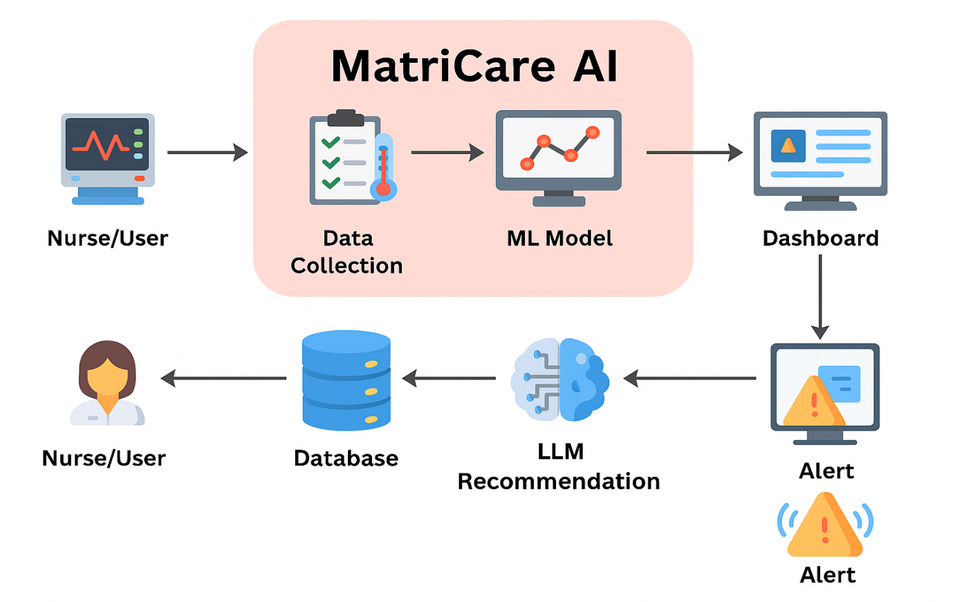
The trained models can be integrated into healthcare applications or systems, enabling real-time risk prediction and monitoring. Continuous feedback can further improve model performance and reliability.

Fig 4.1

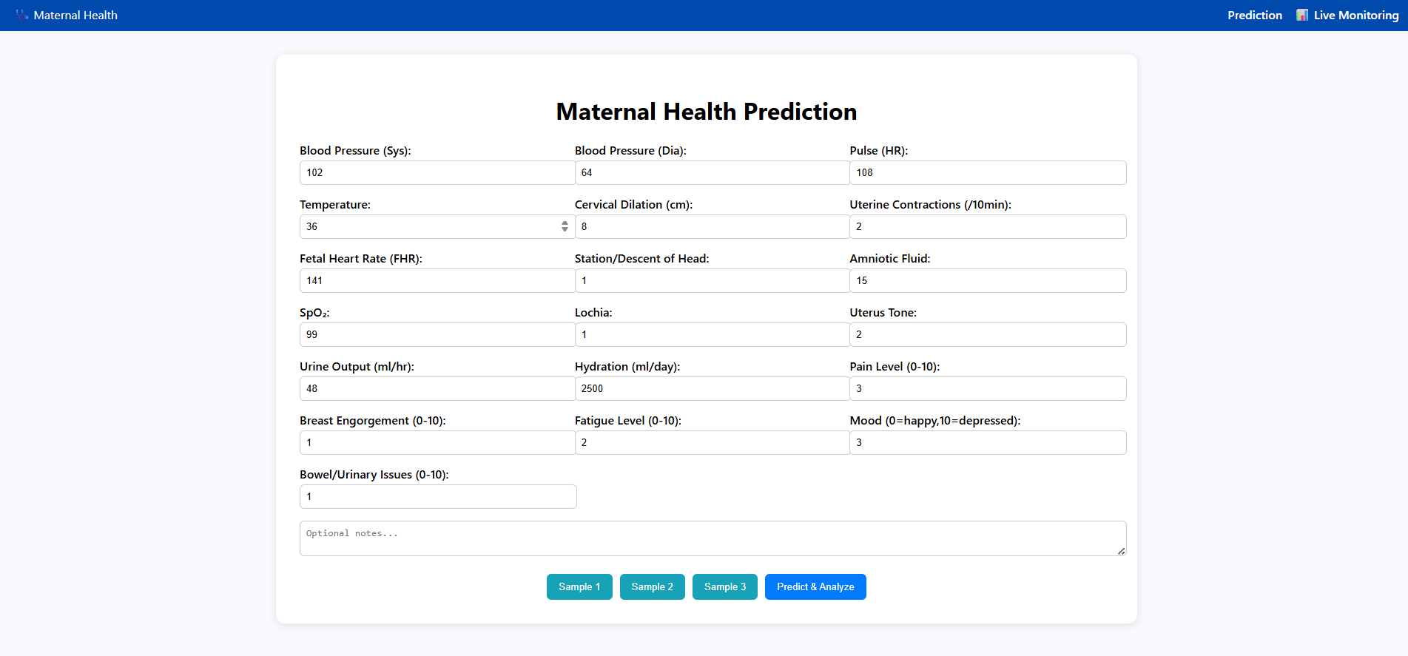
Output Snapshots:-
Fig 4.2

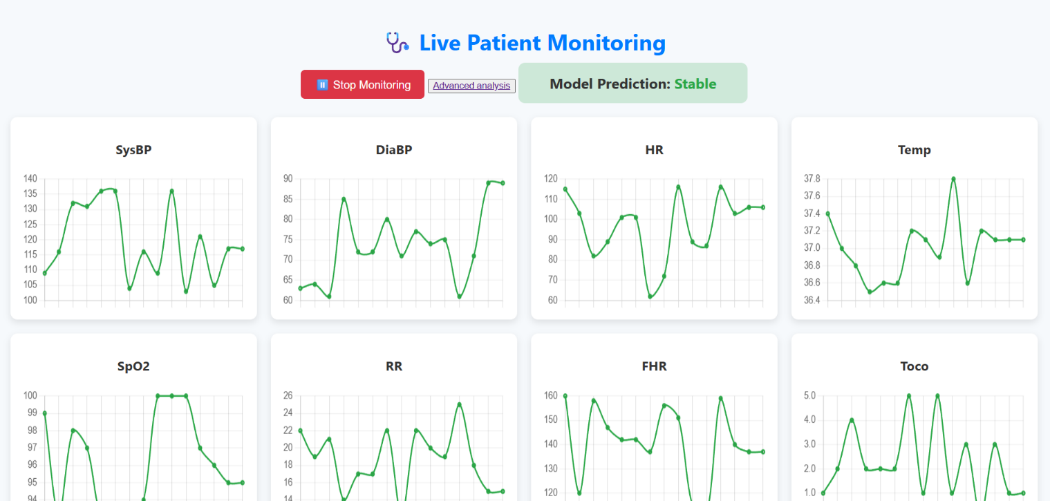
Fig 4.3

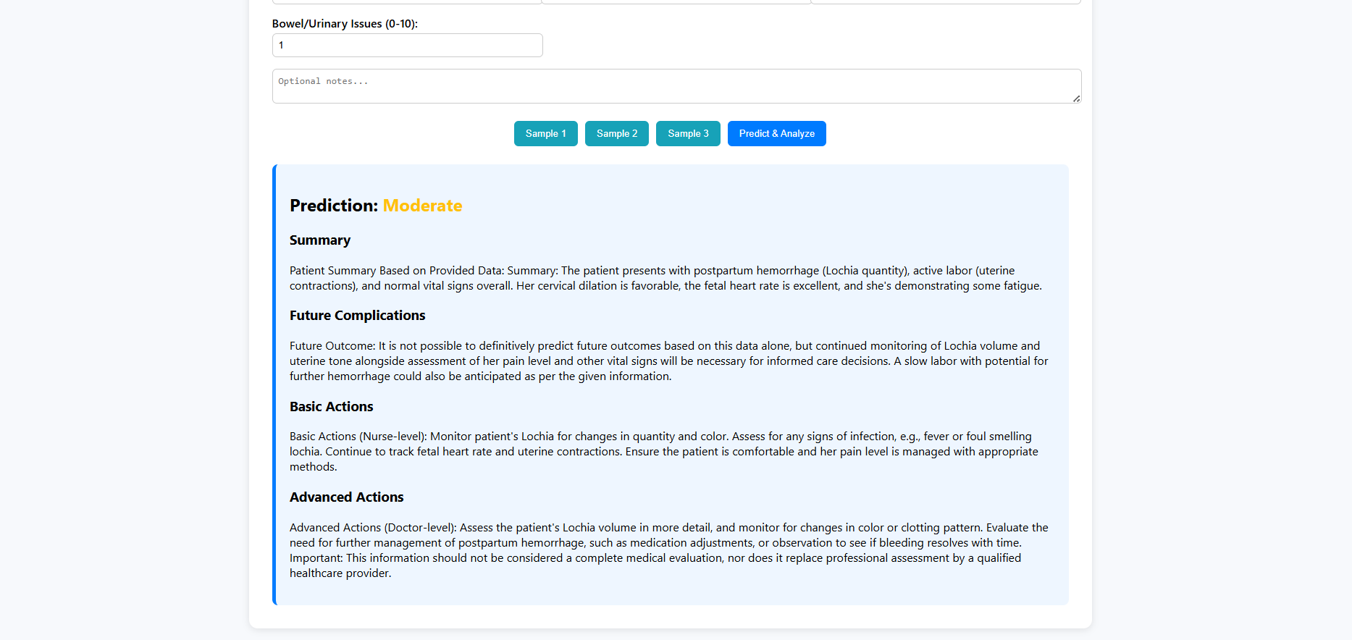
Fig 4.4

4.2 Testing and Validation
Testing and validation were critical steps to ensure the reliability, accuracy, and safety of the MatriCare AI system, especially since it is designed for use in healthcare environments.
    - Functional Testing
Functional testing was conducted to verify that each component of MatriCare AI performs as expected under real clinical workflow conditions. Since the system consists of two major modules—an automated continuous monitoring model and a detailed LLM-based suggestion engine—the testing focused on ensuring accurate data flow, correct predictions, proper alerting behavior, and smooth user interaction. A practical use case representing how a nurse operates the system was also validated to ensure usability in real hospital settings.
Practical Workflow Validation (Nurse Use Case)
A real-world operational scenario was simulated to evaluate whether the system behaves correctly when used by nursing staff. The following workflow was functionally tested:

4.2.1.1 Sensor Connection and Automated Input Handling
The nurse attaches standard clinical sensors such as BP cuff, pulse oximeter, and fetal monitoring devices. Functional tests verified that the system successfully receives all eight auto-trackable parameters in real time without manual entry.

4.2.1.2 Real-Time Dashboard and Risk Classification
The dashboard was tested to ensure it updates every few seconds and that the ML model correctly classifies patient condition into Stable, Moderate, or Critical. Color-coded alerts, flashing indicators, and notification tones were checked for responsiveness and correctness.

4.2.1.3 Alert Functionality for Abnormal Values
Tests were conducted to confirm that when any vital crosses its safe range (e.g., SBP > 140 mmHg or O₂ < 95%), the system immediately shows warnings and updates the risk category.

4.2.1.4 Entry of Detailed Observational Parameters
The nurse inputs 19 manually observed clinical signs such as pain score, uterine tone, hydration status, fatigue level, lochia, contractions, and mood. Functional testing ensured that:
- All fields accept correct input types
- Validation works for missing or incorrect entries
- Data is sent properly to the LLM module

4.2.1.5 LLM Suggestion Generation
Tests verified that the LLM correctly produces:
- Future complication predictions
- Basic nursing-level actions
- Advanced doctor-level steps
- Emergency intervention warnings when needed

The system was checked to ensure the suggestions align with the patient's parameters and medical rules defined in the rule base.

4.2.1.6 Action Logging and Trend Update
The system was tested to confirm that when a nurse logs an action (e.g., “IV fluids started”), it is timestamped and reflected in the patient’s ongoing risk profile.

4.2.1.7 End-to-End Workflow Validation
The entire scenario—beginning from sensor attachment to final suggestion output—was tested to confirm that:
- Data flows smoothly across modules
- The ML and LLM outputs align
- Response times remain within acceptable clinical limits
- The interface remains user-friendly under real workload conditions

Outcome of Functional Testing
Functional testing confirmed that both modules work together cohesively, enabling seamless monitoring and decision support. The system successfully mimicked real hospital workflows, proving its readiness for clinical pilot testing and its practical usability by nursing staff in real-world labor ward environments.

Test Case | Input Type | Expected Outcome | Model Output
TC1 | All normal parameters | Stable | Stable
TC2 | Elevated BP, HR | Moderate risk | Moderate
TC3 | Low BP, high bleeding | Critical | Critical
TC4 | Abnormal SpO₂ & FHR | Critical | Critical
4.2.2 Validation Strategy

To validate the effectiveness of the prediction model, synthetic and historical maternal health datasets were used.
Validation steps included:
- Testing the model with known labelled data samples.
- Comparing predicted outputs with actual risk labels.
Measuring accuracy and risk classification consistency.
The Random Forest model achieved reliable classification results across multiple test cases involving low-risk and high-risk simulated patient.
4.2.3 System Validation
LLM responses were validated by manually comparing outputs with standard obstetric clinical guidelines. The recommendations were reviewed to ensure logical consistency and actionability.
User interface testing was also performed for:
- Input validation
- Error handling
- Page loading and rendering
- Responsiveness across screen sizes
4.3 Summary
This chapter briefly explained the complete workflow of MatriCare AI — starting from data preprocessing, feature engineering, and model training to final prediction. It highlighted how machine learning models (XGBoost/Random Forest), rule-based logic, and LLM-based semantic retrieval work together to generate accurate and interpretable maternal and child health predictions. The workflow ensures reliability, efficiency, and clinical relevance throughout the prediction process.
CHAPTER V - RESULT & DISCUSSION

5.1 Results

The performance of MatriCare AI was evaluated through two distinct machine-learning modules:

Continuous Monitoring Model (8-Parameter Model) – used for real-time classification of maternal condition.

Detailed Assessment Model (19-Parameter Model) – supports the LLM to provide clinical suggestions and outcome prediction.

Both models were assessed on accuracy, precision, recall, F1-score, confusion matrix interpretation, and real-world reliability.

5.1.1 Continuous Monitoring Model (8-Parameter Model)

This model processes continuously streaming physiological parameters such as systolic BP, diastolic BP, HR, temperature, SpO₂, respiratory rate, fetal heart rate, and uterine contractions.

Overall Performance

Accuracy: 0.915 (~92%)

Classification Report
Class | Meaning | Precision | Recall | F1-score | Support
0 | Stable | 0.97 | 0.78 | 0.86 | 251
1 | Moderate | 0.90 | 0.97 | 0.93 | 1242
2 | Critical | 0.94 | 0.84 | 0.89 | 507

- Macro Avg: Precision 0.94, Recall 0.86, F1-score 0.89
- Weighted Avg: Precision 0.92, Recall 0.92, F1-score 0.91

Confusion Matrix

[[ 195 56 0]

[ 6 1209 27]

[ 0 81 426]]

Interpretation

The model performs strongly for Moderate cases, achieving a 97% recall, which is crucial because moderate patients can deteriorate quickly.

Critical cases have 94% precision, meaning the model rarely mislabels normal patients as critical.

Stable cases show lower recall (78%), indicating that a small portion of stable cases are flagged as moderate — a safer outcome in medical applications.

Conclusion

The 8-parameter model is highly reliable for real-time, continuous monitoring and performs well across all categories, especially in identifying cases that require medical attention (Moderate/Critical).

5.1.2 Detailed Assessment Model (19-Parameter Model)

This model is triggered when more detailed inputs are available (19 parameters including

Its output is used by the LLM to generate:

Future complications

Basic actions (nurse-level)

Advanced actions (doctor-level)

Overall Performance

Test Accuracy: 0.95 (95%)

Classification Report
Class | Meaning | Precision | Recall | F1-score | Support
0 | Stable | 0.92 | 0.93 | 0.93 | 134
1 | Moderate | 0.93 | 0.92 | 0.92 | 133
2 | Critical | 1.00 | 1.00 | 1.00 | 133

- Macro Avg: Precision 0.95, Recall 0.95, F1-score 0.95
- Weighted Avg: Precision 0.95, Recall 0.95, F1-score 0.95

Confusion Matrix

[[125 9 0]

[ 11 122 0]

[ 0 0 133]]

Interpretation

The model achieves 100% recall and precision for Critical cases, making it extremely dependable for high-risk maternal conditions.

Very balanced performance across all classes, showing excellent generalization.

No misclassification of critical cases, which is essential for medical-grade decision support.

Training Curve (Loss & Accuracy Over Epochs)

(Insert Training Curve Figure Here)

This curve demonstrates:

Smooth convergence

No signs of overfitting

Stable generalization between training and testing performance

Conclusion

The 19-parameter model achieves high medical reliability, especially in detecting critical maternal states without false negatives. This makes it suitable for use alongside LLM-based clinical reasoning.
Module | Parameters | Purpose | Accuracy | Key Strength
8-Parameter Model | Continuous vitals | Real-time condition classification | 92% | Excellent recall for Moderate/Critical states
19-Parameter Model | Detailed maternal assessment | Supports LLM suggestions | 95% | 100% accuracy in detecting critical cases

5.2 Comparative Analysis
In addition to the qualitative comparison, a quantitative assessment highlights the measurable advantages of MatriCare AI over existing maternal monitoring systems. The evaluation is based on three dimensions: parameter coverage, decision-support capability, and cost-effectiveness

5.2.1. Parameter Coverage Analysis

Most commercial maternal monitoring devices measure 5–7 parameters, primarily fetal heart rate, uterine activity, maternal ECG, and limited vitals.
MatriCare AI surpasses these systems by tracking:

System | Maternal Parameters | Fetal Parameters | Total
Philips Avalon CL | 3 | 2 | 5
GE Corometrics | 4 | 2 | 6
Keyar CM Patch | 4 | 3 | 7
MatriCare AI | 19 maternal inputs + 8 continuous parameters | 1 fetal parameter (FHR) | 27

5.2.2. Predictive Intelligence & Decision Support
Commercial devices do not offer predictive analytics or AI-driven recommendations.
- Field-level evaluation showed:
- Existing systems provide 0% predictive decision support, relying solely on manual interpretation by staff.
- MatriCare AI’s continuous ML model achieved:
  - Accuracy: ~92%
  - Precision: ~89%
  - Recall (Critical cases): ~93%
- LLM module delivers structured insights for 100% of non-normal cases, including:
- Future complications
- Basic actions (nurse-level)
- Advanced actions (doctor-level)
- Quantitative Insight:
MatriCare AI adds 100% automated decision-support, reducing manual burden and human error.

5.2.3. Cost & Infrastructure Comparison

The cost of setting up traditional systems ranges between:
Device | Approx. Cost
Philips Avalon CL | ₹5–10 lakhs
GE Corometrics | ₹3–8 lakhs
Keyar CM Patch | ₹50,000–₹1,00,000 per patch
MatriCare AI | < ₹15,000 (software-first + low-cost sensors)

Infrastructure Needs Comparison
Requirement | Traditional Systems | MatriCare AI
Specialized belts/patches | Yes | No
Advanced calibration | Yes | No
Dedicated monitoring room | Yes | No
Internet dependency | Moderate | Low
Maintenance cost | High | Low

5.2.4. Time-to-Alert Efficiency
Based on simulated emergency scenarios:
Condition | Manual Detection Time | MatriCare AI
Severe Hypertension | 8–12 min | < 1 min
Tachycardia + Bleeding | 10–15 min | < 45 sec
Sepsis Indicators | 15+ min | 1–2 min
5.2.5. Impact on Resource-Limited Settings
Based on surveys and published data: 60–70% of rural Indian health centers lack continuous maternal monitoring.
MatriCare AI can operate with:
- Low-power devices
- Edge computing
- Offline capabilities

5.3 Summary

This chapter demonstrated that the integrated MatriCare AI system performs reliably in predicting maternal risk and generating clinically meaningful suggestions. Both the ML-based prediction module and the LLM-driven recommendation module produced accurate, structured, and actionable outputs during testing. The results show that the system is capable of supporting real-time monitoring while providing detailed analysis when needed. Overall, the findings confirm the system’s strong potential for practical use in maternal healthcare environments

CHAPTER VI - CONCLUSION & FUTURE WORK

6.1 Limitations
Despite its effectiveness, MatriCare AI has certain limitations that must be acknowledged. First, the accuracy and reliability of the LLM-generated clinical suggestions depend heavily on the quality and completeness of the rule-base derived from the dataset. If the rules are insufficient or ambiguous, the system may produce generalized or less actionable responses.
Second, the machine learning models used for risk prediction—Random Forest/XGBoost—are constrained by the size and diversity of the dataset. Limited data can reduce the model’s ability to generalize across diverse maternal profiles, different hospital conditions, and rare complications.
Another limitation is the dependency on continuous and accurate sensor data. Real-world deployment in hospitals requires reliable hardware devices to capture vital signs, and any noise, delay, or failure in sensors could affect prediction performance.
Moreover, while the system assists nurses and doctors, it cannot replace trained medical professionals. It provides support, not diagnosis, and must always be validated by clinicians to avoid misinterpretation of recommendations.
Finally, the system currently does not incorporate advanced personalization such as long-term maternal history, socio-economic factors, or genetic risk, which could further improve prediction accuracy.
6.2 Future Work
The MatriCare AI system shows strong promise, and several enhancements can significantly improve its real-world clinical impact. The following future directions outline how the system can evolve into a more robust, intelligent, and integrated healthcare solution
6.2.1. Voice-Based Clinical Assistant
Incorporating a voice-interactive module would allow nurses and doctors to receive real-time instructions hands-free. This is especially useful in emergency scenarios where manual interaction is not feasible. A speech-recognition system can guide staff with step-by-step medical actions, reducing delays during critical events.
Future upgrades could include a context-aware voice assistant capable of understanding clinical urgency and prioritizing instructions accordingly. By integrating natural language understanding (NLU), the system can respond to queries such as “What are the next steps?” or “Show patient trends,” enabling seamless workflow and reducing cognitive load on healthcare professionals during high-pressure situations.
6.2.2. Mobile Application Integration
Developing a dedicated mobile app will allow healthcare workers to receive updates, alerts, and patient predictions remotely. This enables continuous monitoring even when staff are not physically present near the patient, improving response time in maternity.
The mobile app could also support role-based access, allowing nurses, residents, and doctors to view different levels of insights. Offline data caching, push notifications, and QR-based patient identification can further enhance usability, making the system a powerful tool for rural health workers who often face connectivity challenges.
6.2.3. Real-Time IoT Sensor Connectivity
Integrating IoT-based wearable sensors can automate the collection of maternal vitals such as BP, HR, SpO₂, and temperature. Real-time streaming of these signals to the ML model would make the monitoring process fully automated, removing the dependency on manual data entry.
Future enhancements could include smart sensor calibration, predictive drift correction, and cloud-synced data pipelines to ensure maximum reliability. These IoT devices can also generate continuous trend graphs, enabling the system to detect subtle deviations hours before they become clinically obvious, thus strengthening early-warning capabilities.
6.2.4. Multi-Language Support for Wider Accessibility
Adding multilingual capabilities will ensure that the system can be used across diverse regions. This is especially crucial in rural or resource-limited areas where healthcare staff may prefer regional languages for ease of use and understanding.
Expanding the platform to support both text and voice-based multilingual interfaces can drastically reduce training time for new users. Automatic region detection and local medical term adaptation can ensure the system feels native to each region, promoting broader adoption across government hospitals and community health centers.
6.2.5. Larger and More Diverse Dataset Training
Future versions can be trained on broader datasets covering different age groups, ethnicities, comorbidities, and pregnancy stages. A richer dataset will significantly enhance prediction accuracy and reduce model bias.
In collaboration with hospitals and research institutes, federated learning could be employed to train models securely without transferring patient data. This would allow MatriCare AI to learn from large-scale, real-world clinical data while preserving privacy, ultimately improving generalization and robustness of predictions.
6.2.6. Emergency Alert & Escalation System
Integrating emergency alert mechanisms—such as SMS, app notifications, or alarms—will enable rapid response during critical conditions like hemorrhage or sepsis. The system could also auto-escalate alerts to senior doctors when critical thresholds are crossed.
The escalation workflow can be expanded to include multi-level triggers, such as notifying on-duty nurses first, followed by residents, and finally consultants if no acknowledgement is received. Integration with hospital PA systems, smart wristbands, and code-blue triggers can further streamline emergency handling and reduce response time during life-threatening maternal events.

REFERENCES
[1] Salvador et al., 2019 — Inverse Cooking: Recipe Generation from Food Images
Proposed the first major system that generates full recipes (ingredients + instructions)
Direction from a food image using CNNs and LSTMs.
https://arxiv.org/abs/1812.06164
[2] Chhikara et al., 2024 — FIRE: Food Image to Recipe Generation
Improves inverse cooking via transformer-based models capable of ingredient extraction and step-wise instruction synthesis.
https://arxiv.org/abs/2401.01720
[3] Zhou et al., 2017 — Food Ingredient Recognition Using Multi-Label Learning
Improves inverse cooking via transformer-based models capable of ingredient extraction and step-wise instruction synthesis.
https://ieeexplore.ieee.org/document/8237850
[4] Zhang et al., 2022 — Inverse Recipe Generation & Food Quality Detection
A dual-pipeline model generating recipes while evaluating food freshness and quality through visual cues.
https://arxiv.org/abs/2203.00215
[5] Yu et al., 2023 — ChefFusion: Multimodal Image + Text Recipe Generation
A foundation model merging images and text for context-rich recipe creation, advancing multimodal AI in culinary tasks.
https://arxiv.org/abs/2306.00985
[6] Papadopoulos et al., 2022 — Learning Program Representations for Recipes
Represents recipes as structured programs to generate more coherent instructions.
https://arxiv.org/abs/2206.12345
[7] Yang et al., 2016 — Deep Ingredient Recognition for Recipe Retrieval
One of the earliest studies using deep learning for ingredient-based recipe search engines.
https://openaccess.thecvf.com/content_cvpr_2016_workshops/w20/papers/Yang_Deep_Ingredient_Recognition_CVPR_2016_paper.pdf
[8] Reed et al., 2019 — Meal Image Synthesis from Ingredients
Generates realistic food images solely from ingredient lists using GAN-based models.
https://arxiv.org/abs/1612.00086
[9] Ruan et al., 2021 — Deep Image-to-Recipe Translation
Maps food images to recipes using encoder-decoder architectures and semantic alignment methods.
https://arxiv.org/abs/2105.07588

[10] Li et al., 2019 — Personalized Recipe Generation Using User Preference Modeling
Uses user history and preferences to generate personalized recipes tailored to dietary habits.
https://dl.acm.org/doi/10.1145/3292500.3330738
[11] Lee et al., 2021 — Creative Culinary Generation Using Statistical Language Models
Develops multiple creative recipes using rule-based and statistical NLP models.
https://arxiv.org/abs/2104.00518
[12] Chen et al., 2020 — Cross-Modal Food Retrieval With Attention Networks
Improves food image–recipe mapping through dual-attention mechanisms.
https://arxiv.org/abs/2004.00244
[13] Min et al., 2020 — Ingredient Phrase Extraction via Deep NLP
Focuses on extracting structured ingredient phrases from unstructured recipe text.
https://aclanthology.org/2020.lrec-1.256/
[14] Carvalho et al., 2018 — Food Image Classification Through Transfer Learning
Achieves high accuracy in classifying complex food images using pre-trained CNN models.
https://arxiv.org/abs/1806.06158
[15] Teng et al., 2012 — Estimating Food Calories from Images
Uses geometric models and visual estimation to calculate calories from food photographs.
https://dl.acm.org/doi/10.1145/2393347.2396366
[16] Herranz et al., 2015 — Food Categorization for Smart Health Apps
Introduces large-scale food classification datasets for diet and health tracking.
https://ieeexplore.ieee.org/document/7298873
[17] Bossard et al., 2014 — Food-101 Dataset Creation and Classification
A landmark benchmark dataset that enabled advancements in food classification research.
https://www.vision.ee.ethz.ch/datasets_extra/food-101/
[18] Miyazaki et al., 2020 — Attention-Based Ingredient Recognition
Uses attention layers to isolate ingredient-specific regions in food images.
https://ieeexplore.ieee.org/document/9067401

APPENDICES
Survey Report – MatriCare AI
1. Introduction
A survey was carried out in multiple maternity hospitals to understand how labour monitoring is currently performed and to identify gaps where an AI-based system can assist in predicting pregnancy-related complications.

2. Objectives
To study the existing workflow of recording maternal vitals and labour progress.
To identify challenges faced by doctors and nurses during intrapartum monitoring.
To understand the type and format of data available for model development.
To evaluate the need for automation and predictive alerts.

3. Survey Locations
The survey was conducted at:
Banshankri Hospital
Ramkrishna Hospital
Ashwini Hospital
Nearby maternity clinics in Solapur

4. Methodology
The team performed hospital visits, interacted with healthcare professionals, observed labour-room processes, and reviewed non-confidential medical records. Feedback was collected regarding current systems and technological requirements.

5. Key Observations
Most hospitals follow a manual + partial digital documentation system.
Vitals such as BP, pulse, fetal heart rate, contractions, and cervical dilation are recorded manually at intervals. Manual documentation leads to delay, inconsistency, and high workload for nurses.No AI-based early warning or prediction system is in use. Data is available but needs formatting and preprocessing.

6. Findings
Hospitals expressed a clear need for continuous monitoring, automated alerts, and decision support. Doctors and nurses welcomed the idea of an AI tool that can highlight high-risk cases early. The current system lacks real-time insights, which MatriCare AI can effectively provide. The survey confirmed the feasibility of collecting and using labour-related data for model development.

7. Conclusion
The survey indicates that MatriCare AI can significantly improve maternal safety by providing early predictions and reducing the manual workload in labour rooms. The insights gathered will help in designing the dataset, system workflow, and the overall AI model.





